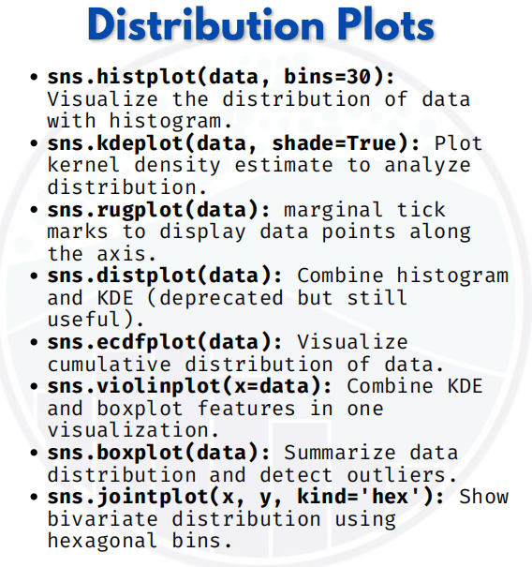

Distribution plot

1. Histogram
import seaborn as sns
import matplotlib.pyplot as plt

# Sample data
tips = sns.load_dataset("tips")
# Histogram of 'total_bill'
sns.histplot(tips['total_bill'], bins=30)
plt.show()
Shows how total_bill values are distributed.

2. KDE Plot (Kernel Density Estimate)
sns.kdeplot(tips['total_bill'], shade=True)
plt.show()
Smooth curve showing distribution (probability density)

3. Rug Plot
sns.rugplot(tips['total_bill'])
plt.show()
Adds small tick marks on the axis for each data point.

4. Distplot (Deprecated but useful)
sns.distplot(tips['total_bill'], bins=30, kde=True)
plt.show()
Combines Histogram + KDE in one plot.

5. ECDF Plot (Empirical Cumulative Distribution Function)
sns.ecdfplot(tips['total_bill'])
plt.show()
Shows cumulative percentage of data points.

6. Violin Plot
sns.violinplot(x=tips['day'], y=tips['total_bill'])
plt.show()
Shows distribution + KDE + boxplot inside.

7. Box Plot
sns.boxplot(x=tips['day'], y=tips['total_bill'])
plt.show()
Shows median, quartiles, and outliers.
8. Joint Plot
sns.jointplot(x='total_bill', y='tip', data=tips, kind='hex')
plt.show()
Bivariate distribution with hexagonal bins.

So in short:
- histplot / kdeplot / rugplot / ecdfplot → for distribution of single variable
- boxplot / violinplot → compare distributions across categories
- jointplot → relationship between two variables

